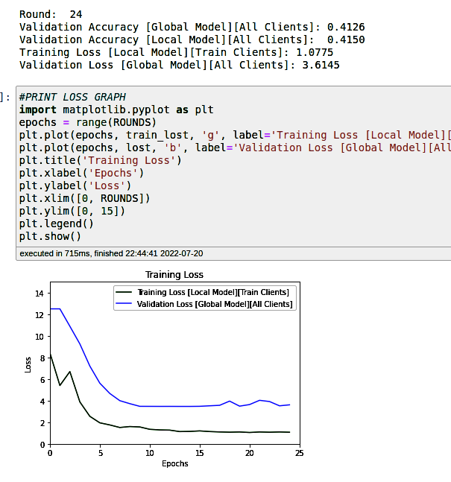
neighbors updated each round after round 5
heads v1 = 2
conv layers = 1

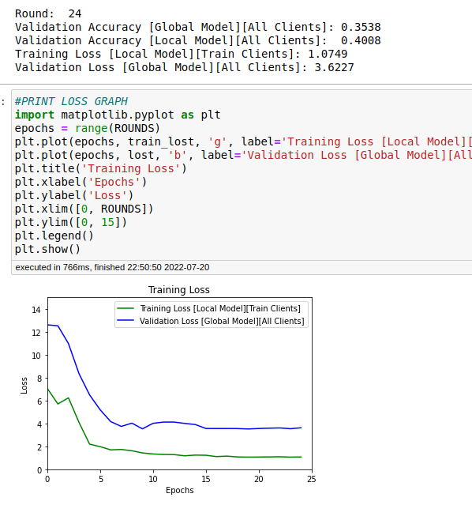
neighbors updated at round 2
heads v1 = 2
conv layers = 1

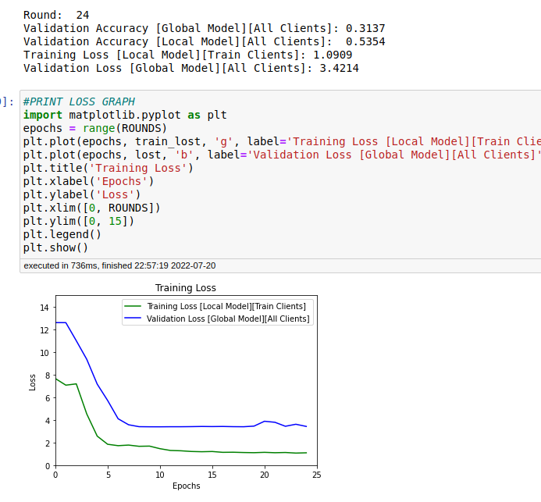
Including no neighbors
conv layers = 1
heads = 2

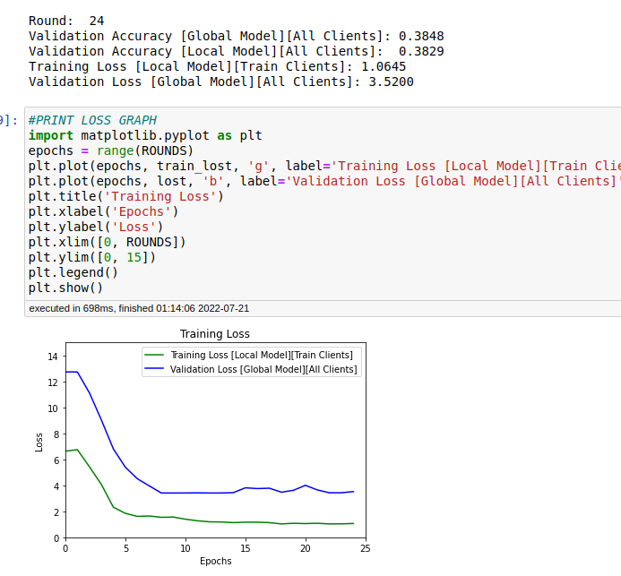
neighbor at 5

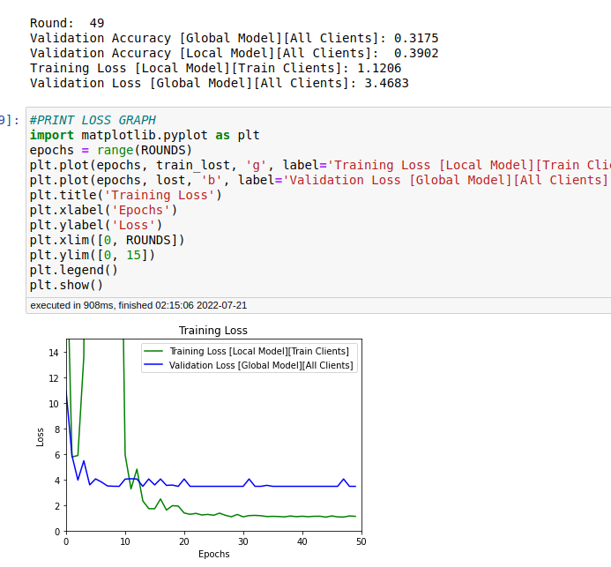
neighbor: 5
2 conv
head 1: 4
head 2: 1

